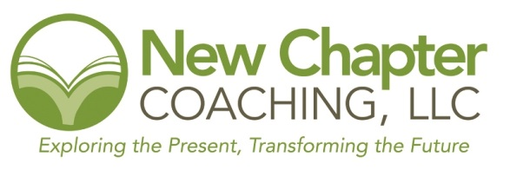

Common Board Issues

What are the main weaknesses, omissions, mistakes, flaws, bad judgments, and sins that a board or an individual board member can commit? This is a list of several ways that a governing board can lose its way.

- Veering off the mission (Clean your glasses, get focused!)
The most important decision-making guideline for a board is the mission statement. If the mission is not a central theme at every board meeting, it can be easy for a board to lose focus of the organization’s true purpose and veer into mission creep. Example: A youth education organization accepts a generous grant to build a sports facility for young people.

2. Complacency (I don’t know surely they know better?)
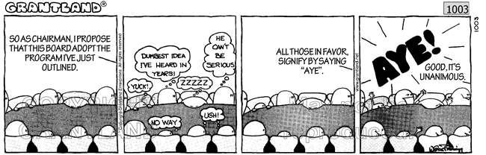
A core obligation of every board member is active participation. Some symptoms of being unengaged can include board members who put off their assignments and not being accountable, disregard the core responsibilities, fail to ask questions, or miss meetings. Example: A board member does not know how to analyze financial statements. Instead of asking questions, he votes with the majority.

3. Misguided motivations (I care, but maybe about the wrong things.)
Board members must always think of the organization first, the Duty of Loyalty Misguided and unethical motivations, undeclared conflicts of interest, and the pursuit of personal benefit can endanger the organization’s tax-exempt status. Example: A board member recruits an out-of-work relative to run the organization.

4. Multiple voices (Who said that?)
Boards speak with one voice, which is formulated through deliberation. Individual board members are bound by the collective decision. Differing opinions need to be resolved in the boardroom, not declared outside the organization. Example: A board member is interviewed by the press and advocates for her own solution - one not adopted by the board.

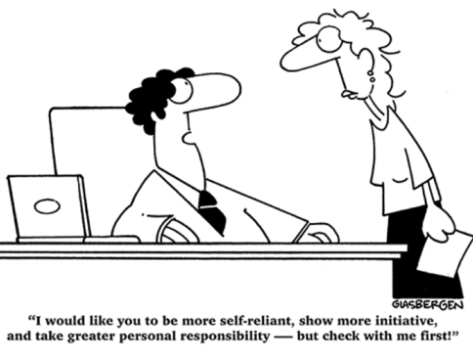
5. Micromanaging (I can do that!)
One of the key duties of a board is to hire a competent chief executive to run daily operations. Part of this duty assumes that there is a valid job description and a performance evaluation process in place. A board’s role is to oversee that the organization is well run by strategically monitoring; not engage in operation. Example: The board insists on being involved in choosing a new computer system for the organization.

6. Limitless terms (Black robes, only for the Supreme Court.)
Every board must accept and even thrive on change. New perspectives and different ideas keep a board and organization moving forward. Term limits can help boards avoid stagnation. Example: Fearful of losing control, the founding board of an organization has been governing for 15 years.

7. Lawless governance (Asleep at the wheel.)
Nonprofit tax-exempt organizations must heed federal, state, and local regulations, as well as their own bylaws. It is the board’s role to make sure that all laws are respected. The board needs to assure that the organization files its Form 990 correctly and on time; that employment taxes are withheld regularly; and that official documents are saved appropriately. If a board fails to adopt appropriate policies or to effectively oversee financial regulations, it may become liable for wrong doings. Example: To get through a temporary financial crunch, the chief executive decides not to pay payroll taxes for several months. The board is unaware that this is happening.

8. No self-assessment (Know thyself!)
By studying its own behavior, sharing impressions, and analyzing the results, a board is able to lay the groundwork for self-improvement. Failing to assess its own performance, a board is unable to define its strengths and weaknesses. As a by-product, it can also enhance its team spirit, its accountability, and its credibility. Example: Board members’ morale is low, attendance is sporadic, and the chair has no clue about how to energize the board.

9. Lack of self-improvement (Ignorance is no excuse.)
Self-improvement is one of the innate consequences of self-assessment. Regular self-assessment is a futile process if it does not address apparent weaknesses in a board and result in structured self-betterment. Boards that do not provide learning possibilities for their members miss opportunities and inefficiently utilize their members’ abilities. Example: Board members have never seen individual board member job descriptions and are not familiar with their legal obligations.

10. Knotted purse strings (Blinding George Washington.)
Asking for and giving money are natural aspects of being a board member in most 501(c)(3) charities. Boards that are responsible for fundraising, yet don’t have a 100% board personal contribution rate, have failed the ultimate commitment test. If the board is not supporting the organization, how can it convince others to do so? Example: A board is not able to reach consensus on its personal contribution policy. It becomes divided due to feelings of unfairness and lack of commitment.

Adapted from the Boardsource Knowledge Center

